|  |
| --- |
|  |
| 新概念 3 册 |
| Lesson31 A lovable eccentric |

Book

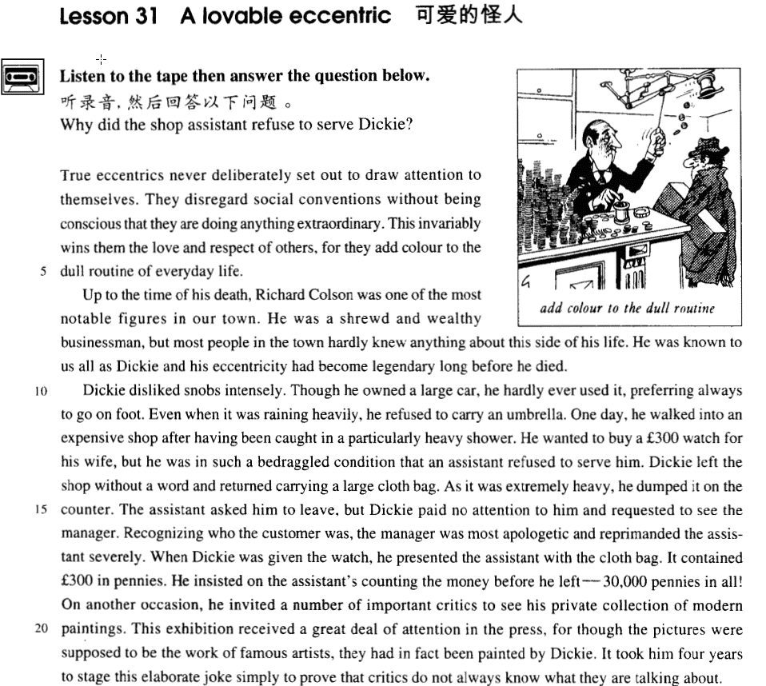

课文

True eccentrics never deliberately set out to draw attention to themselves.

真正古怪的人从不有意引人注意。

They disregard social conventions without being conscious that they are doing anything extraordinary.

他们不顾社会习俗，意识不到自己所作所为有什么特殊之处。

This invariably wins them the love and respect of others, for they add colour to the dull routine of everyday life.

他们总能赢得别人的喜爱与尊敬，因为他们给平淡单一的日常生活增添了色彩。

Up to the time of his death, Richard Colson was one of the most notable figures in our town.

理查德.科尔森生前是我们镇上最有名望的人之一。

He was a shrewd and wealthy businessman, but most people in the town hardly knew anything about this side of his life.

他是个精明能干、有钱的商人，但镇上大部分人对他生活中的这一个方面几乎一无所知。

He was known to us all as Dickie and his eccentricity had become legendary long before he died.

大家都管他叫迪基。早在他去世前很久，他的古怪行为就成了传奇故事了。

Dickie disliked snobs intensely.

迪基痛恨势利小人。

Though he owned a large car, he hardly ever used it, preferring always to go on foot.

尽管他有一辆豪华小轿车，但却很少使用，常常喜欢以步代车。

Even when it was raining heavily, he refused to carry an umbrella.

即使大雨倾盆，他也总是拒绝带伞。

One day, he walked into an expensive shop after having been caught in a particularly heavy shower.

一天，他遇上一场瓢泼大雨，淋得透湿。

He wanted to buy a ￡300 watch for his wife, but he was in such a bedraggled condition that an assistant refused to serve him.

他走进一家高级商店，要为妻子买一块价值300英镑的手表，但店员见他浑身泥水的样子，竟不肯接待他。

Dickie left the shop without a word and returned carrying a large cloth bag.

迪基二话没说就走了。一会儿，他带着一个大布口袋回到店里。

As it was extremely heavy, he dumped it on the counter.

布袋很沉，他重重地把布袋扔在柜台上。

The assistant asked him to leave, but Dickie paid no attention to him and requested to see the manager.

店员让迪基走开，他置之不理，并要求见经理。

Recognizing who the customer was, the manager was most apologetic and reprimanded the assistant severely.

经理认出了这位顾客，表示了深深的歉意，还严厉地训斥了店员。

When Dickie was given the watch, he presented the assistant with the cloth bag.

店员为迪基拿出了那块手表，迪基把布口袋递给他，

It contained ￡300 in pennies.

口袋里面装着300镑的便士。

He insisted on the assistant's counting the money before he left -- 30,000 pennies in all!

他坚持要店员点清那些硬币后他才离去。这些硬币加在一起共有30,000枚！

On another occasion, he invited a number of important critics to see his private collection of modern paintings.

还有一次，他邀请一些著名评论家来参观他私人收藏的现代画。

This exhibition received a great deal of attention in the press, for though the pictures were supposed to be the work of famous artists, they had in fact been painted by Dickie.

这次展览引起报界广泛注意，因为这些画名义上是名家的作品，事实上是迪基自己画的。

It took him four years to stage this elaborate joke simply to prove that critics do not always know what they are talking about.

他花了4年时间策划这出精心设计的闹剧，只是想证明评论家们有时并不解他们所谈论的事情。

词汇讲解

* **lovable**  ['lʌvəbl] adj.（人或动物）可爱的

**lovable / loveable** （两种拼写）

* a **lovable** eccentric / actor / dog

【近义词】

**adorable** ***adj.*** 可爱的；可敬重的，值得崇拜的

**endearing** ***adj.*** 可爱的；讨人喜欢的；引起爱情的

**winsome** ***adj.*** 迷人的；可爱的；引人注目的

**cute** ***adj.*** （强调小的可爱）可爱的；漂亮的；聪明的，伶俐的

* a **cute** baby / puppy / kitten

**beloved *adj.*** 心爱的；挚爱的

* my **beloved** wife / husband
* **eccentric** [ɪk'sentrɪk] n. 古怪的人；adj. 异常的，古怪的

**eccentric** （无贬义含义）

**eccentricity** ***n.*** 古怪；怪癖

* One of his **eccentricities**（怪癖） is sleeping under the bed.

【发音近似】

**exhibit**

**exhibition**

【近义词】

**freak** （贬义）***adj.*** 奇异的，反常的

**oddball** （贬义）***adj.*** 古怪的；奇怪的

**weirdo** （贬义）***n.*** 古怪的人，奇怪的人

**sicko** （强烈贬义）***n.*** 道德败坏的人；神经有问题的人

**pervert**（强烈贬义）***n.*** 堕落者；行为反常者；性欲反常者；变态

* **老友记**
* Phoebe: Oh that’s good, I guess she’ll have a choice between my guy and your **weirdo**.
* Chandler: Why would our guy be a **weirdo**?
* Phoebe: Because that’s just your taste.
* **老友记**
* Rachel: Oh my God! That's Monica!!
* Joey: Oh no-no-no! No-no-no-no-no!
* Rachel: You get away from me!! You sick, sick, sick, **sicko**!!
* Ross: What's going on?
* Rachel: Joey has got a secret peephole!
* Chandler: Oh no! No! No! No!
* Rachel: Yes! He has a naked picture of Monica! He takes naked pictures of us! And then he eats chicken and looks at them!
* Rachel: Look!
* Ross: Dude! That's my sister!
* Monica: Give me that!
* Phoebe: All right, wait! Just wait. Everybody just calm down. Okay? Let's give our friend Joey a chance to explain why he's such a big **pervert**!
* Joey: No! I am not a **pervert**! Okay?
* **disregard** [dɪsrɪ'ɡɑ:d] v. 漠视，不顾，不理睬

【近义词】明明看到，装没看见、不理睬

**disregard**

**ignore** ***vt.*** 驳回诉讼；忽视；不理睬

* You shouldn’t **disregard / ignore** safety problems.
* **考试真题：**
* When I saw Jane, I stopped and smiled, but she ___B___ me and walked on.

[A] refused [B] ignored

[C] denied [D] missed

【近义词】忽视，没有注意到

**neglect** ***vt.*** 疏忽，忽视；忽略

**overlook** ***vt.*** 忽略；

* **考试真题：**
* The joys of travel, having long ___C___ the disabled, are opening up to virtually anyone who has the means(钱).

[A] omitted [B] missed

[C] neglected [D] discarded

【近义词组】

**pay no attention to ...** 根本不理睬

**take no notice of ...**

**turn a deaf ear to ...** 充耳不闻

**turn a blind eye to …** 视而不见

* **convention** [kən'venʃn] n. 习俗，风俗，惯例
* **social conventions**  社会习俗
* **accepted conventions**  公认习俗
* **international conventions** 国际惯例

【近义词】惯例、习俗

**custom**

**tradition**

**institution**

**practice**

* On the other hand, your stomach would turn at the idea of frying potatoes in animal fat—the normally accepted **practice** in many northern countries.

【同根词】

**conventional** ***adj.*** 符合习俗的，传统的；常见的；惯例的

* conventional values 约定俗成的/传统的价值观
* conventional lifestyle 传统的生活方式
* conventional measures 常规/传统的措施

【近义词】

**traditional** ***adj.*** 传统的；惯例的

**customary *adj.*** 习惯的；通常的

* **conscious** ['kɒnʃəs] adj. 感觉到的，意识到的

**be conscious of ...** 意识到…

= **be conscious (of the fact) that ...** 意识到…

= **be aware of ...** 意识到…

= **be aware (of the fact) that ...**

【反义】

**be unconscious of ...** 没有意识到

= **be unconscious (of the fact) that ...**

= **be unaware of ...**

= **be unaware (of the fact) that ...**

【同根词】

**consciousness** ***n.*** 意识；知觉；觉悟；感觉

* enhance people’s **consciousness** of public morality*.
* **intensely** [ɪn'tenslɪ] adv. 强烈地intense

**intense** ***adj.*** 强烈的；紧张的；非常的；热情的

* **intense** heat / cold / pain 酷热/严寒/剧痛
* intense love / hatred / suffering 强烈的爱/恨/痛

**intensive *adj.*** 加强的；集中的；透彻的；加强语气的

* an **intensive** English course.
* two weeks of **intensive** negotiations.
* **intensive** **reading** 精读
* **extensive** **reading** 泛读
* **labor-intensive** industry 劳动密集型产业
* **capital-intensive** industry 资本密集型产业
* **technology-intensive** industry 技术密集型产业
* **knowledge-intensive** industry 知识密集型产业
* **apologetic** [əpɒlə'dʒetɪk] adj. 道歉的，表示歉意的

**be apologetic about ...** 对某事表示歉意

* He was **apologetic** about his late arrival.

**apologize** ***vi.*** 道歉；辩解；赔不是 ***vt.*** 道歉；谢罪；辩白

**apologize to sb. for sth.** 因为某事向某人道歉

* He **apologized to me for** his late arrival.

**apology *n.*** 道歉；谢罪；辩护；勉强的替代物

**make an apology to sb. for sth.** 因为某事向某人道歉

**owe sb. an apology** 欠某人一次道歉

**say sorry to sb. for sth.** 因为某事向某人道歉

* **reprimand** ['reprɪmɑ:nd] v. 训斥，批评（上下级）

reprimand

【近义词】**rebuke**

**reprimand / rebuke sb. for sth.** 因为某事批评某人（上下级）

* I was **reprimanded** / **rebuked** by my manager **for** being late.

【近义词组】

**accuse sb. of sth.** 因为某事气愤的指责某人

* Dimitri immediately went to Aleko's house and angrily **accused** him **of** stealing the lamb.

**criticize sb. for sth.** 因为某事批评某人（无特殊含义）

* He was **criticized for his** delay in dealing with the matter.

**censure sb. for sth.** 严厉批评某人

* Ministers were **censured for** their lack of decisiveness* during the crisis.

**scold sb. for sth.** 批评某人（长辈对晚辈）

* His mother **scolded him for** breaking her favorite vase.

**reproach sb. for sth.** 因为未作某事而指责某人

* He **reproached me for** not answering his letter.

**blame sb. for sth.** 因为某事批评某人（强调责任）

**blame sth. on sb.**

* They **blamed** George **for** the failure.
* They **blamed** the failure **on** George.

**condemn A for / as B** 谴责

* The movie was **condemned for** its sexism.
* The terrorist attack **was condemned as** an act of barbarism* and cowardice*.
* **stage** [steɪdʒ] v. 组织，策划，举行，举办

**stage**: organize

* **stage a strike / a riot / a plot / a coup / an exhibition** 组织罢工/暴动 / 阴谋 / 政变/展览
* China **staged** the 2008 Olympics.

课文讲解

# （第一段）

# True eccentrics never deliberately set out to draw attention to themselves.

知识点（1）

**deliberately** 故意的、蓄意的、存心的

= **on purpose**

= **intentionally**

知识点（2）

**set out to do**: begin a job, task, etc with a particular aim or goal 带着目的去做某事

* The journalist immediately **set out to obtain** these important facts, but he took a long time to send them.
* Dmitri at once **set out to find** the thief.
* **美剧：**
* We never **set out to hurt** you, Victor.
* And I'm sorry we did.
* Are you done?
* Yeah.

**set out / off** （单独使用，不强调特殊方式）动身触发

**start out / off**

* Four days after **setting out**, while the Titanic was sailing across the icy waters of the North Atlantic, …
* After making a short test flight at 4.15 a.m., Bleriot **set off** half an hour later.

知识点（3）

**draw (one’s) attention** 吸引（某人）注意力

**= attract / capture / catch / arrest / command / get (one’s) attention**

* This **attracted the attention of** Richard Humphries who was then the most eminent boxer in England.

**receive (one’s) attention** 受到（某人）关注

* This exhibition **received** a great deal of **attention** in the press, …

# They disregard social conventions without being conscious that they are doing anything extraordinary.

**语法分析：**

They disregard social conventions *without(原因状语) being conscious that（看作省略of的从句，或看作that的引导的形容词补足语） they are doing anything* ***extraordinary****（形容词修饰不定代词后置）.*

知识点（1）

* **课文写法替换：介词短语做状语**
* without **being conscious (of the fact) that** …
* without **being conscious of** ...
* without **being aware (of the fact) that** ...
* without **being aware of** ...
* People tend to amass possessions, sometimes **without being aware of** doing so.
* **课文写法替换：非谓语**
* **(being) unconscious (of the fact) that ...**
* **(being) unconscious of ...**
* **(being) unaware (of the fact) that ...**
* **(being) unaware of ...**
* He used to sleep during the day and work at night, quite **unaware of the fact that** he had become the ghost of Endley.
* They disregard social conventions, **quite unconscious / unaware of the fact that** they are doing anything extraordinary.
* **造句**: 他们无视安全问题, 意识不到自己的所作所为有什么危险之处。
* They disregard safety problems, without **being conscious that** they are doing anything dangerous.
* They disregard safety problems, quite **unconscious / unaware of the fact that** they are doing anything dangerous.

# This invariably wins them the love and respect of others, for they add colour to the dull routine of everyday life.

**语法分析：**

This invariably wins them（间接宾语） *the love and respect of others（直接宾语）*, for they add colour to the dull routine of everyday life. （原因状语)

知识点（1）

**invariably**: always 总是

知识点（2）

**win sb. sth.** 为某人赢得了…

**win sth. for sb.** 为某人赢得了…

* My sincerity **won me her heart**.
* My sincerity **won her heart for me**.

知识点（3）

**add color to sth.** 增添颜色（使更有趣）

* Intelligent use of metaphors can **add color to** your writing.

【近义词组】

**add luster / lustre to sth.** 给…增添光泽（使更有趣）

**add flavor / spice to sth.** 给…增添风味（使更有趣）

**add variety to sth.** 增加多样性（使更有趣）

知识点（4）

**dull** ***adj.*** 钝的；迟钝的；无趣的；呆滞的；阴暗的

**boring** ***adj.*** 无聊的；令人厌烦的

**monotonous *adj.*** 单调的，无抑扬顿挫的；无变化的

写作补充：课文中用dull更好一下，dull本身有“暗淡的”含义，与前面colour接应，双关

* **造句**: 网上冲浪总是能赢得年轻人的痴迷(fascination), 因为它给平淡的日常生活增添了一丝亮色。
* Surfing the Net invariably wins itself the fascination of the young, for it adds color to the dull routine of everyday life.

# （第二段）

# Up to the time of his death, Richard Colson was one of the most notable figures in our town.

知识点（1）

**up to ...** **含义1**：直到；做时间状语

= **up until ...**

= **up till ...**

= **until ...**

补充：一般不用till（不正式），一般不放在句首

**up to ...** **含义2**：不少过、最多…；

= **less than ...**

* In Europe, taxes account for **up to**（最高）four-fifths of the retail price.

知识点（2）

**notable** ***adj.*** 值得注意的，显著的；著名的

* ... 'the most valiant soldier and most **notable** leader, Signor Giovanni Haukodue'.

知识点（3）

**figure** 重要的人物

* One of the most colorful **figures** in boxing history was Daniel Mendoza who was born in 1764.

# He was a shrewd and wealthy businessman, but most people in the town hardly knew anything about this side of his life.

**语法分析：**

He was a shrewd and wealthy businessman, but most people in the town hardly knew anything *about this side of his life. （后置定语，修饰anything）*

知识点（1）

**“this side of his life”**避免和前面的重复

->“his shrewdness and wealthiness”

* Harry is very thrifty, but in the presence of his friends he never shows ***this side of his life*** (= *his thriftiness*).

# He was known to us all as Dickie and his eccentricity had become legendary long before he died.

**语法分析：**

He *was known* to us all *as* Dickie **and** his eccentricity had become legendary long(adv.长久的) before he died（时间状语）**.**

知识点（1）

**know sb./sth. as sth.** 把…称为是…

* The disease **is** commonly **known as** Mad Cow Disease.
* He soon made a name for himself and came **to be known** to the Italians **as** Giovanni Acuto.
* **造句**：美国人把 Earvin Johnson 称为魔术师约翰逊 (Magic Johnson)。
* Earvin Johnson **is known *to*** the Americans **as** ‘Magic Johnson’.
* **造句**：中国人把李白称为诗仙 (poet immortal)。
* Li Bai **is known *to***the Chinese **as** ‘poet-immortal’.

知识点（2）

**legendary** ***adj.*** 传说的，传奇的

* Robin Hood is a legendary hero.

= **famous** / **well-known** 著名的

* the **legendary**（著名的） Hollywood director Steven Spielberg
* The Chinese are **legendary**（著名的） for their hospitality.
* **造句**：在上梁山前很久，武松的力量和勇敢就已经很有名了。
* Wu Song’s strength and courage had become legendary **long before** he joined the Liangshan rebels.

# （第三段）

# Dickie disliked snobs intensely.

* 课文写法替换：**动词**
* Dickie **hated / abhorred / detested / loathed / abominated** snobs intensely.
* 课文写法替换：**形容词**
* Dickie found snobs **repellent / repulsive / revolting / disgusting**.
* 课文写法替换：“**令讨厌”**
* Snobs **repelled / repulsed / revolted / disgusted** Dickie intensely.

# Though he owned a large car, he hardly ever used it, preferring always to go on foot.

**语法分析：**

Though he owned a large car（让步状语从句）, he hardly ever used it, *preferring always to go on foot（非谓语动词引导原因状语)*.

知识点（1）

**hardly ever** （时间频率副词，只能表示时间）几乎从来没有发生过

= **almost never**

= **seldom**

= **rarely**

知识点（2） 复习：Lesson14

**prefer to do rather than do** 更愿意…而不愿意…

* ..., **preferring** always **to go** on foot **rather than go in his car**.
* **造句**：尽管他有几个保镖 (bodyguard)，但他很少让他们陪着他 (accompany him)，总是更喜欢独自一个人 (on his own) 去散步 (take a stroll)。
* Though he owned several bodyguards, he hardly ever asked them to accompany him, **preferring** always **to** take a stroll on his own.

# Even when it was raining heavily, he refused to carry an umbrella.

* 课文写法替换：**“下大雨”**
* It’s raining **hard**（程度副词） / **heavily**.
* It’s **pouring**.
* It’s raining **cats and dogs**.

# One day, he walked into an expensive shop after having been caught in a particularly heavy shower.

知识点（1） 复习：Lesson04

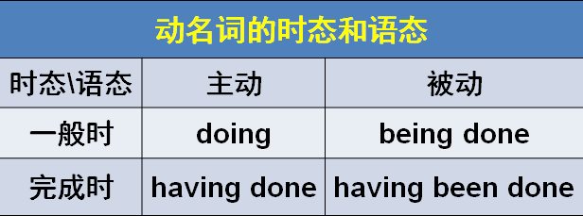

**语法**：动名词的时态和语态。完成时强调时间更早一些；一般时没有场合限制，完成时有场合限制

知识点（2）

* … **after**（介词） having been caught in a particularly heavy shower.
* … **after**（连词） he had been caught in a particularly heavy shower.

知识点（3） 复习：Lesson25

**be caught in ...** 赶上了（通常遭遇了不好的事，被困住了）

* He **was caught in** a storm / traffic jam.

**be struck by …** 遭遇到了（严重的、倒霉的事）…

* In August, she **was struck by** a very heavy storm during which her rudder was torn away.

# He wanted to buy a ￡300 watch for his wife, but he was in such a bedraggled condition that an assistant refused to serve him.

**语法分析：**

He wanted to buy a £300 watch for his wife, but he was in *such* a bedraggled condition *that an assistant refused to serve him（结果状语）.*

知识点（1）复习：Lesson06

**金钱 + worth of + 物品** 价值…钱

* a ￡300 **worth of** watch

知识点（2）

* 课文写法替换：**so…that…**
* ... but he was **so bedraggled** **that** ...
* His family was **so impoverished** ***that*** he could hardly afford his tuition.
* His family was in **such an impoverished condition** ***that*** he could hardly afford his tuition.

知识点（3）

**serve sb. with sth.** 把…给某人拿过来

= **serve sth. to sb.**

* ... refused to **serve him with the watch**.
* ... refused to **serve the watch to him**.

# Dickie left the shop without a word and returned carrying a large cloth bag.

**语法分析：**

Dickie left the shop without a word and returned carrying a large cloth bag（做return的伴随状语）.

【谚】**take French leave** 一语不发的离开

【谚】Dumb dogs are dangerous. 咬人的狗不叫

# As it was extremely heavy, he dumped it on the counter.

知识点（1）

extremely heavy

= **weigh a ton** 重一吨（【习语】特别沉）

= **The chair weighs a ton.**

= The chair is extremely heavy.

知识点（2）

英语中模拟**“声音”**的动词

* …, he **dumped** （噔的一声）it on the counter.
* He **slammed** （啪的一声）the door.
* We all **clapped**（papa鼓掌） our hands.
* The soldier **clicked**（咯噔） his heels.
* Don’t **clatter**（咣当咣当） the dishes — you’ll wake the baby up.
* I’ll **smack** （pia的一声） your bottom if you don’t behave yourself.

# The assistant asked him to leave, but Dickie paid no attention to him and requested to see the manager.

知识点（1）

Dickie **paid no attention to** him

= Dickie **ignored** him.

= Dickie **took no notice of** him.

= Dickie **turned a deaf ear to** him.

= Dickie **turned a blind eye to** him.

知识点（2）

request 客气的请求

* You’re **requested** （请求）not to smoke here.
* You’re **required**（命令） not to smoke here.

# Recognizing who the customer was, the manager was most apologetic and reprimanded the assistant severely.

**语法分析：**

Recognizing who the customer was（宾语从句）（非谓语动词引导原因状语), the manager was **most**（及其，=extremely） apologetic and reprimanded the assistant severely.

# When Dickie was given the watch, he presented the assistant with the cloth bag.

知识点（1）

**写作：**课文使用被动，**避免频繁的变换主语**

* When the assistant gave **Dickie** the watch, **Dickie** presented the assistant with the cloth bag.

**使用被动避免频繁的变换主语，举例：**

* **She** gave a lecture on modern American poetry and **was attentively listened to**.
* **The old professor** wheeled himself to the platform and **was warmly applauded** by the students.

知识点（2） 复习：Lesson22

**present sb. with sth.** 呈递给某人

= **present sth. to sb.**

* He entered the cell and **presented** the letter **to the** aristocrat.

# It contained ￡300 in pennies.

**介词in**：用…，以…

* He paid me **in** cash / dollars.
* Write it **in** ink / pencil / English.

# He insisted on the assistant's counting the money before he left -- 30,000 pennies in all!

知识点（1）

**语法：动名词的逻辑主语**；一般来说，动名词的逻辑主语在正式文体中用属格（所有格），在非正式文体中用普通格。在《新概念英语》和考试中，均以正式文体为准。

* Do you mind ***my***smoking here? （正式）
* Do you mind ***me***smoking here? （非正式）
* ***Your***falling into the river was the climax of the whole trip. （正式）
* ***You***falling into the river was the climax of the whole trip. （非正式）

出现下列情况时，即使在正式文体中，动名词的逻辑主语也习惯使用普通格。

**1、逻辑主语为名词指物。**

* The children are looking forward to *spring* coming.

**2、逻辑主语为多个名词。**

* Do you remember *Mary and her mother* coming to see us last June?

**3、逻辑主语为以“s”结尾的名词。**

* It's a disaster *the bosses* shutting all those factories.

**4、逻辑主语与动名词分离。**

* I remember *mother* once telling us a story about the fox.

**5、逻辑主语为不定代词，**如：someone, everything, something; 或指示代词，如：this, that

* They complained about *everything* going wrong.
* He disapproved of *that* being said about Mary.

知识点（2）

**insist on ...** 坚持、要求、命令、建议…

**insist that ..**. （should do）型虚拟语气

* He insisted that the assistant **(should) count** the money before he left, ...
* Even though the noble was expected to read the letter at each performance, he always **insisted that it should be** written out in full.
* 课后题：Lesson 22
* 5．He always insisted ___A___ in full. (1.9)

(a) on its being written out

(b) on writing it out 没有加逻辑主语

(c) to have it written out

(d) that it would have to be written out

* He always insisted on ***its（逻辑主语）***being written out in full.
* Next came a horse, swimming bravely, but we were afraid that the strength of the current would prevent *its* landing anywhere before it became exhausted.
* 课后题：Lesson 56
* 7．The strength of the current would prevent ___B___ anywhere before it ... (124)

(a) that it landed

(b) it from landing

(c) it to land

(d) the landing of it

# On another occasion, he invited a number of important critics to see his private collection of modern paintings.

# This exhibition received a great deal of attention in the press, for though the pictures were supposed to be the work of famous artists, they had in fact been painted by Dickie.

**语法分析：**

This exhibition received a great deal of attention *in the press（介词做状语）*, for *though the pictures were supposed to be the work of famous artists（让步状语从句）*, they had in fact been painted by Dickie. （for引导原因状语)

知识点（1）

**receive + n.** 受到了，得到了…

* No creature has **received** **more praise** and abuse than the common garden snail.
* These young people, who love the peace of the mountains, always **receive** **a warm welcome** at St. Bernard's monastery.

知识点（2） 复习：Lesson05

**the press** 新闻界

* **the freedom of the press** 新闻自由
* In democratic countries any efforts to restrict **the freedom of the press** are rightly condemned.

知识点（3）

work 表作品，可数不可数都可以

# It took him four years to stage this elaborate joke simply to prove that critics do not always know what they are talking about.

**语法分析：**

It（形式主语） took him four years to stage this elaborate joke（真正主语） simply to (动词不定式，引导目的状语) prove *that（宾语从句） critics do not always know what（宾语从句） they are talking about*.

critics do not always know what they are talking about

课文写法替换：

* ... critics do not always **talk sense** （说的有道理）.
* ... critics sometimes **talk nonsense**（胡说八道）.